5.1.1 Leap year checker

ALGORITHM
Step 1 :-Start
Step 2 :- Read the input year
Step 3 :- Check if the year is divisible by 4 and not divisible by 100 and the year is not divisible by 400
Step 4 :- If the condition is true, Display “LEAP YEAR”
Step 5 :- Else Display “NOT A LEAP YEAR”
Step 6 :- Stop

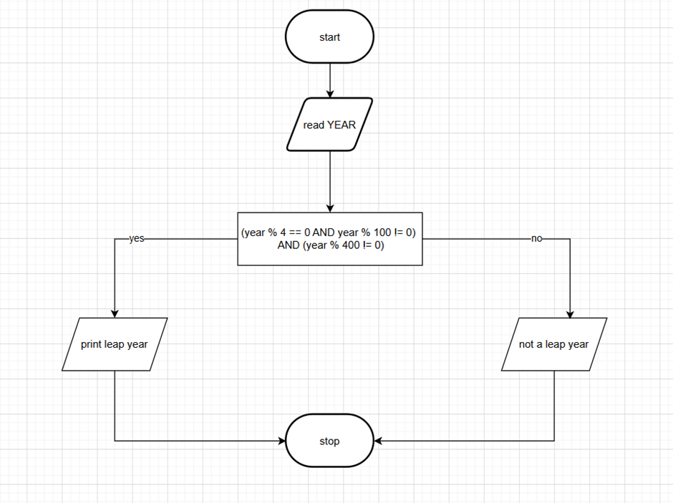

PROGRAM:-

